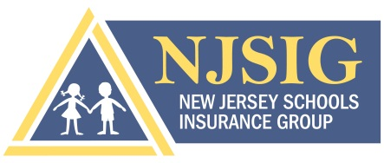

State Funding from the NJ Schools Development Authority (SDA):

The following information is needed for an SDA certificate before we can name these four entities as Additional Insureds:
- State of New Jersey
- The State of New Jersey Department of Education (NJDOE)
- The State of New Jersey Economic Development Authority (NJEDA)
- The State of New Jersey Schools Development Authority (NJSDA)

1. Copy of the SDA Contract section pertaining to the “Insurance Requirements”.

2. Project number(s) supplied by the State (example: 4 digits 3 digits 2 digits 4 digits):

______________________________________________

3. Project name(s) and address (If more than one project each school name and its location/address is needed);

______________________________________________________________________________________

______________________________________________________________________________________

4. Start date(s) / End date(s): ______________________________

5. Estimated cost of project(s): ______________________________

6. Scope of work being done at each location:

______________________________________________________________________________________

______________________________________________________________________________________

______________________________________________________________________________________

______________________________________________________________________________________

______________________________________________________________________________________

7. Certificates of Insurance from all parties who will be working on the construction/project.

*The certificate(s) MUST name as Additional Insured with respects to the project:

- The specific Board of Education
- The State of New Jersey
- The State of New Jersey Department of Education (NJDOE)
- The State of New Jersey Economic Development Authority (NJEDA)
- The State of New Jersey Schools Development Authority (NJSDA)

The GENERAL CONTRACTOR – MUST supply either a manuscript endorsement or
one of the ISO “Additional Insured-Owners, Lessees or Contractors” naming all
parties (listed above) as additional insured.

If NO General Contractor, then ALL contractors working on the project must supply an endorsement.

NOTE: Please keep in mind that if a renewal certificate will be requested in another policy period, the contractor’s certificate(s)/endorsement will need to be updated also.

8. Who currently provides the Builders Risk for this project?

Company Name: ___________________________________________________________________

Policy # _____________________________________________________________________________

Effective Date: _____________________________________________________________________

Please be advised that the Certificate of Insurance provides Limited Builders Risk Coverage for the referenced project(s). Please refer to the NJSIG Property Form NJSIG-P1 Article 1. C. 1. a. (page 4 of 14). It is your responsibility to secure adequate Builders Risk Coverage should you deem such coverage necessary.

